**Saurashtra University-Rajkot**

**A Project Report On**

**Covid-19**

**Health**

**Tracker**

**Kamani Science & Prataprai Arts College**

**Covid-19 Awareness**

**(Corona live Updates)**

**Developed By**

**Urmil Rupareliya**

**Guide By**

**Mr.Ravi Joshi**

**Submitted in partial fulfillment of the requirement**

**For the award of the degree of Bachelor of Computer Applications (BCA)**

**Year of Submission**

**2020-2021**

**Preface**

**The main objective of any computer science student is to get practical Knowledge as possible. Being able to have a practical knowledge by developing a project is a lifetime experience. As practical knowledge is Important as theoretical knowledge we are thankful of having a project.**

**Through the development of the project we had a great experience of various strategies that can be applied in development of the project. This project is the stepping stone for our career.**

**We are pleased to present this project report. Proper case has been taken while organizing the report so that it is easy to comprehend. Also, various software engineering concepts have been implemented.**

# Acknowledgement

**We are student of BCA sem-5 Studying in the Kamani Science Collage, Amreli. We Thanks to the entire person who has given their support in shaping of the system.**

**We thank my friend Smit Bosamiya, Rakesh Sir Savaliya for giving us guidance and Co-operation in understanding the system. We also thank them for their unconditional help in making of this project.**

**We have great deal of gratitude towards our head of department who encourage us in taking up this activity. We thank all faculties and administrative staffs of the institute.**

**Thanks to all**

**Urmil Rupareliya**

**INDEX**

|  |  |  |
| --- | --- | --- |
| No | Title | Page No |
| 1 | **Introduction** | **5** |
| 2 | **Time line Chart** | **6** |
| 3 | **Requirement Specification** | **9** |
| 4 | **Project planning & Scheduling** | **10** |
| 5 | **System analysis** | **11** |
| 6 | **Feasibility Study** | **12** |
| 7 | **Project Page Structure** | **14** |
| 8 | **Data Dictionary** | **15** |
| 9 | **Content Level Diagram** | **18** |
| 10 | **1st Level Diagram** | **19** |
| 11 | **Use Case Diagram** | **20** |
| 12 | **E.R. Diagram** | **21** |
| 13 | **Activity Diagram** | **22** |
| 14 | **Screenshots** | **24** |
| 15 | **Future scope & Bibliography** | **43** |

**Introduction**

The Covid-19 Awareness Site Provide User to number of live cases of corona positive cases.

1) User has to sign up in the site for create account and watch live updates of covid-19(Coronavirus).

2) After sign up user can surf website and get information.

3) User can also give symptoms checking test and get them score.

4) they can see live updates in 3 .

5) User can contact and contribute.

**Time Line Chart**

**Each Segment Specify a Day.**

**Project Profile**

|  |  |  |
| --- | --- | --- |
| * Project Name | : | Covid-19 Awareness  (Covid-19 Health Tracker) |
| * Developed By | : | Urmil Ruparareliya |
| * Front End Tool | : | Php,HTML,Javascript |
| * Back End Tool | : | MySql, Open source API |
| * Operating System | : | Microsoft Windows Xp & Microsoft Window 7 & Windows 10 |
| * Computer System | : | Core to Duo or Higher, RAM: 256 MB |
| * Project Details | : | In this project user can see live updates of corona and they can get more information about corona. |
| * Completion Time | : | 3 Months |
| * Guide By | : | Mr. Joshi Ravi |
| * Submitted By | : | Saurashtra University, Rajkot |

**Hardware Requirement**

* 512+ MB of RAM
* Multimedia Keyboard And Mouse
* 1.0+GHz Processor
* Monitor

**Software Requirement**

|  |  |  |
| --- | --- | --- |
| * Operating System | : | Microsoft Windows XP &Windows 10 and Linux distro |
| * Front End Tools | : | Html, JavaScript, Bootstrap and PHP |
| * Back End Tools | : | MySQL, Open Source API’s & GitHub |
| * Documentation Tools | : | Microsoft Word 2010 |
| * Browser specification | : | Chrome |

**Requirement Specifications**

* **MySQL RDBMS used to maintain the all concerned data.**
* **Uses special views to display data.**
* **Display all types of data using classified reports with combinations of multiple tables.**
* **Special searching for Open source API’s.**
* **Use GitHub for fetch live data worldwide.**

**Problem Definition**

* **Maintain Users Profile**
* **Get research about Corona**
* **Maintain live Cases of corona**
* **Maintain Suggestions**
* **Maintain Contributors**
* **Maintain Contacts**
* **Maintain Users List**

**Project Planning & Scheduling**

**The “Covid-19 Health Tracker” is a system about Coronavirus disease (Covid-19) is an infectious disease caused by a new virus that had not been previously identified in humans. Peoples use this website to learn more about the corona virus disease and keep themselves updated.**

**Before selecting this subject, I have thought that why we are not working on real world projects and at that time I think this corona situation, let me make project that help to peoples who want to know more about corona(Covid-19) and how many cases in your area so they can aware and safe ,and I make this system.**

**System Analysis**

System analysis is the process of identification of objectives and requirements, evaluation of alternative solutions and recommendation for a more feasible solution. In other words, system analysis is the step by step process of gathering, recording and interpreting facts. The main aim of analysis is to determine problem areas and to take solutions to reduce or eliminate them.

* System analysis itself breaks into two stages:

**1. Preliminary analysis**

**2. Detailed analysis**

During analysis, data are collected from the available files, decision points and transactions of the systems using various tools like Data Flow Diagram (DFD).

**Feasibility Study**

A purpose of feasibility study is to check out the possibility of a computerized solution to the organization’s observed problem before very much money that has been spent on.

A feasibility study is carried out to select the best system that meets performance requirements. Only by spending the time to evaluate the feasibility do I reduce the chances for extreme embarrassment at later stage of the system project.

For the complete feasibility study, I need to concentrate on following area:

They are of three types:

1. Technical

2. Operational

3. Economical

* **Technical**

Technical feasibility considers whether the desired project can be completed within the framework of available technology. As our project was website designing, this was not much of a problem, as many advanced web-editing tools are available.

* **Operational**

Operational feasibility was done to assure that the product that would be developed would be used. Since a cards and gifts must have a website of its own sooner or later, that wasn’t much of a problem

* **Economical**

Our Commercial Website is Economically Feasible Because. We have developed this website only for one time. Only future enhancement is required on the other hand every client can view our site any time or many time as per their requirement. So, the future economical expenses are null. So we can say that this website is totally economically feasible.

**Project Page Structure**

* **Client Side**

**Client Side**

**Create Account**

**Login**

**Symptoms checker**

**Covid Live Updates**

**Logout**

**Contact & contribute**

* **Admin Side**

**Admin Side**

**Login**

**Show Users**

**Add/ Show/ Delete suggestion**

**Logout**

**Show/ Delete Contacts**

**Show/ Delete Contribution**

**Manage**

**Questions**

**Data Dictionary**

The data Dictionary is a set of table. MySQL uses it to maintain information about this own database.

* **Data dictionary contains the following information:**
* Name of the table of database.
* User information such as privileges.
* Name and data-type of all columns in database table.

**Database Name: covid19.sql**

**1) Admin:**

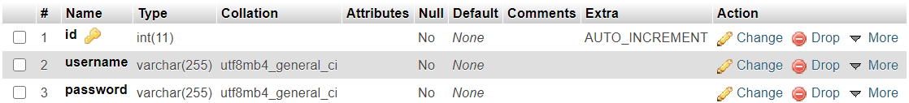

**2) Users:**

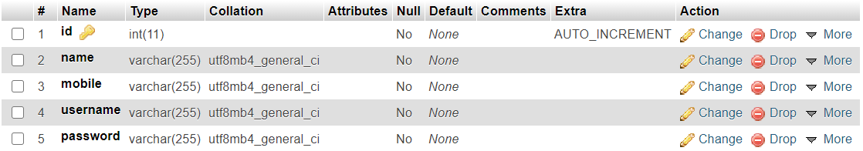

**3) Questions:**

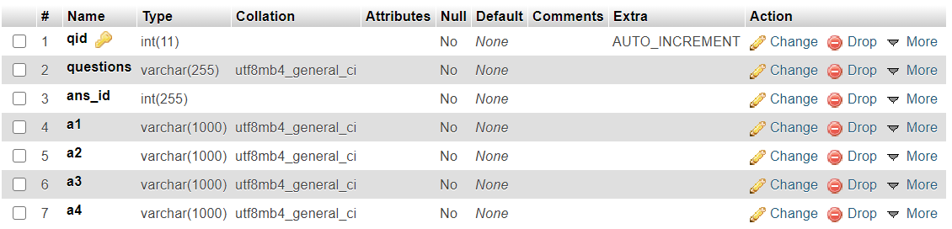

**4) Suggestions:**

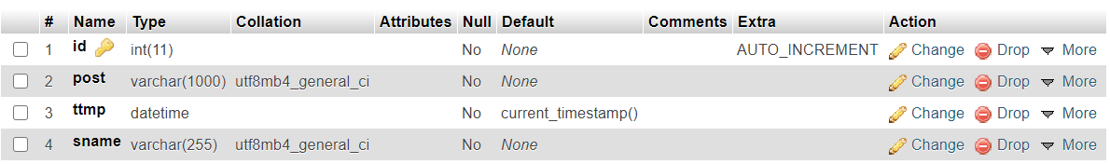

**5) Contributions:**

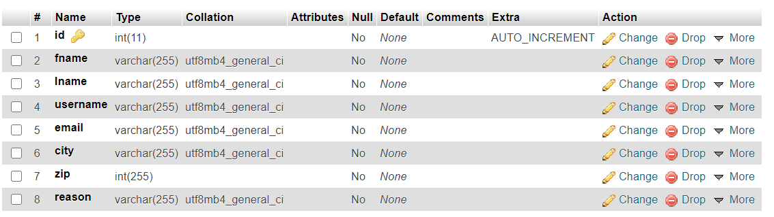

**6) Contact Us:**

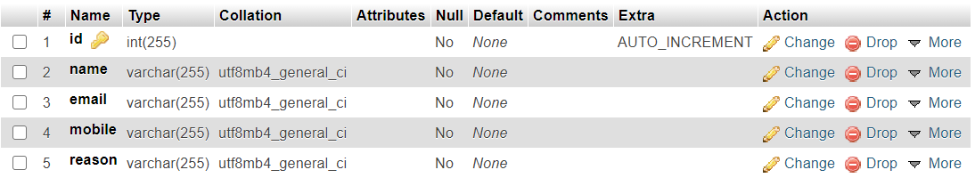

**Context level Diagram (0 Level DFD)**

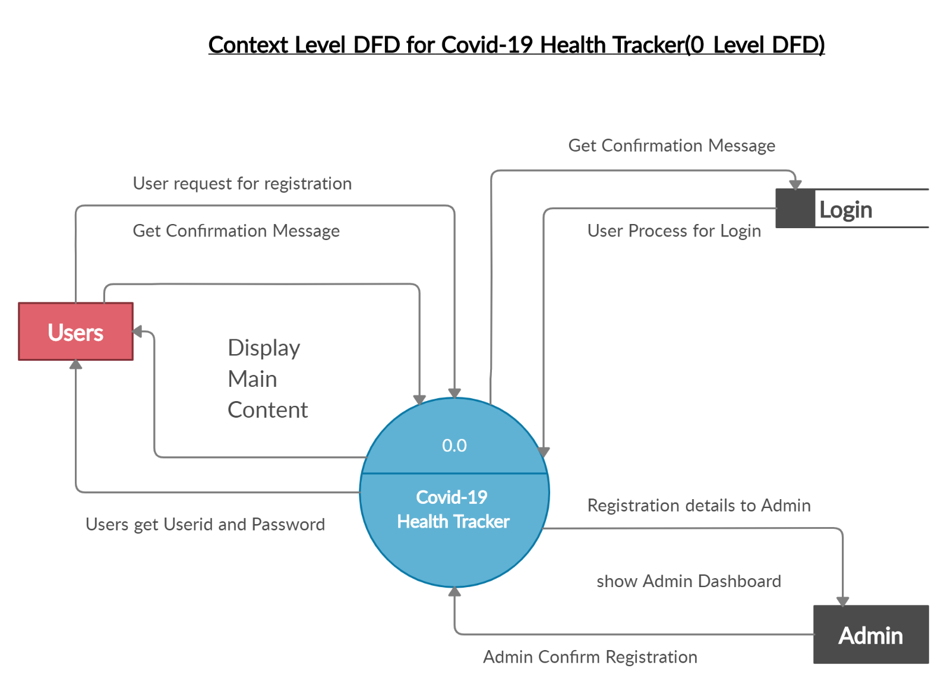

**1st Level Diagram**

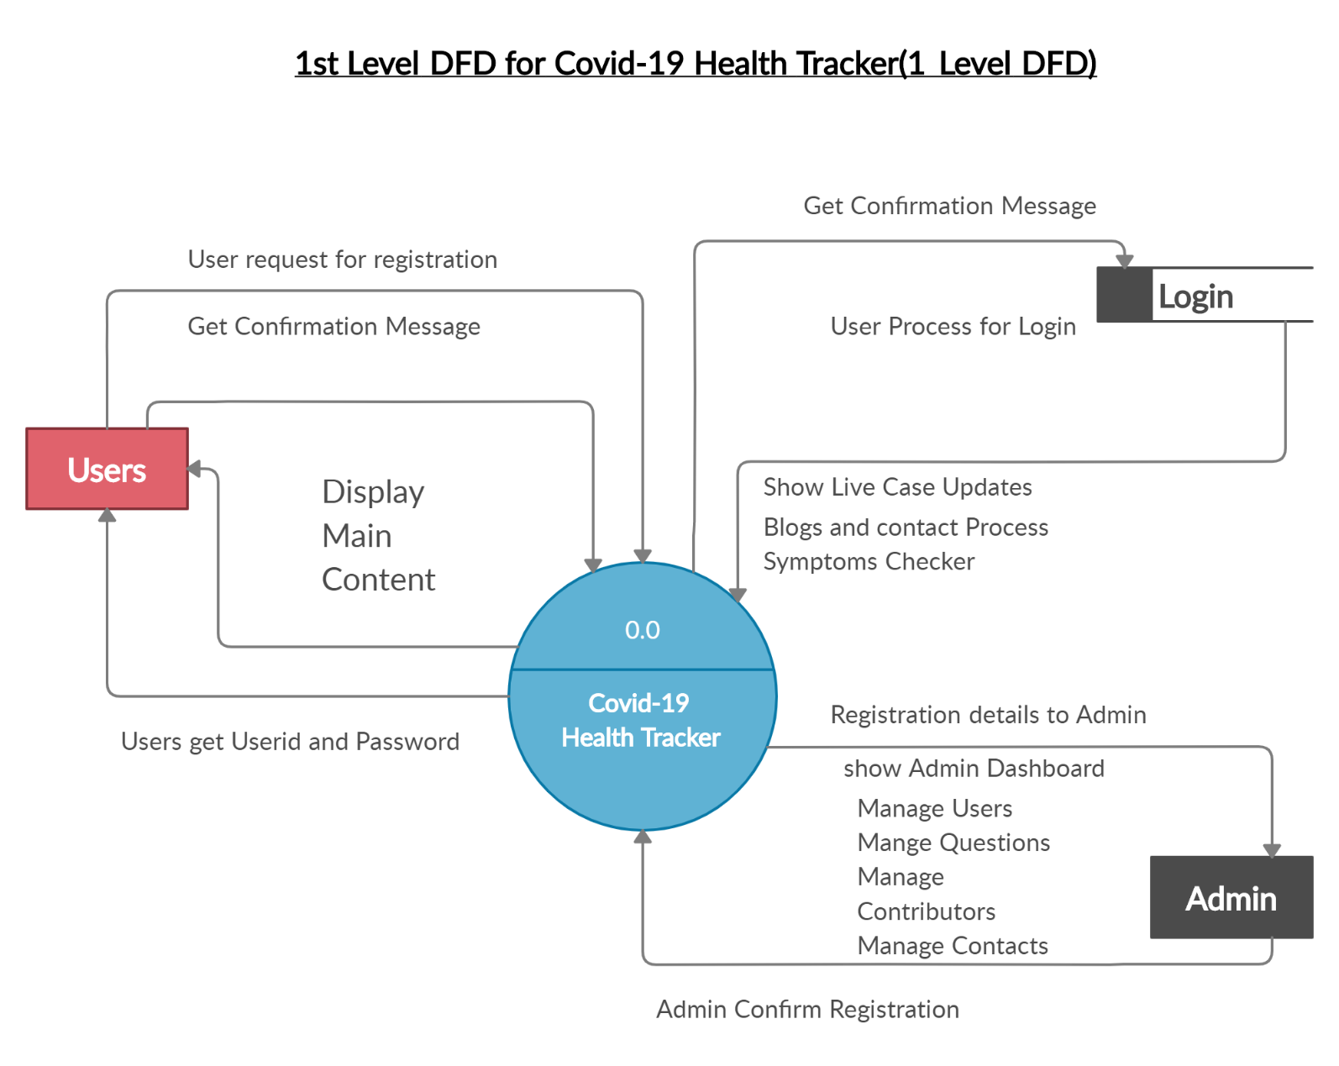

**Use case Diagram**

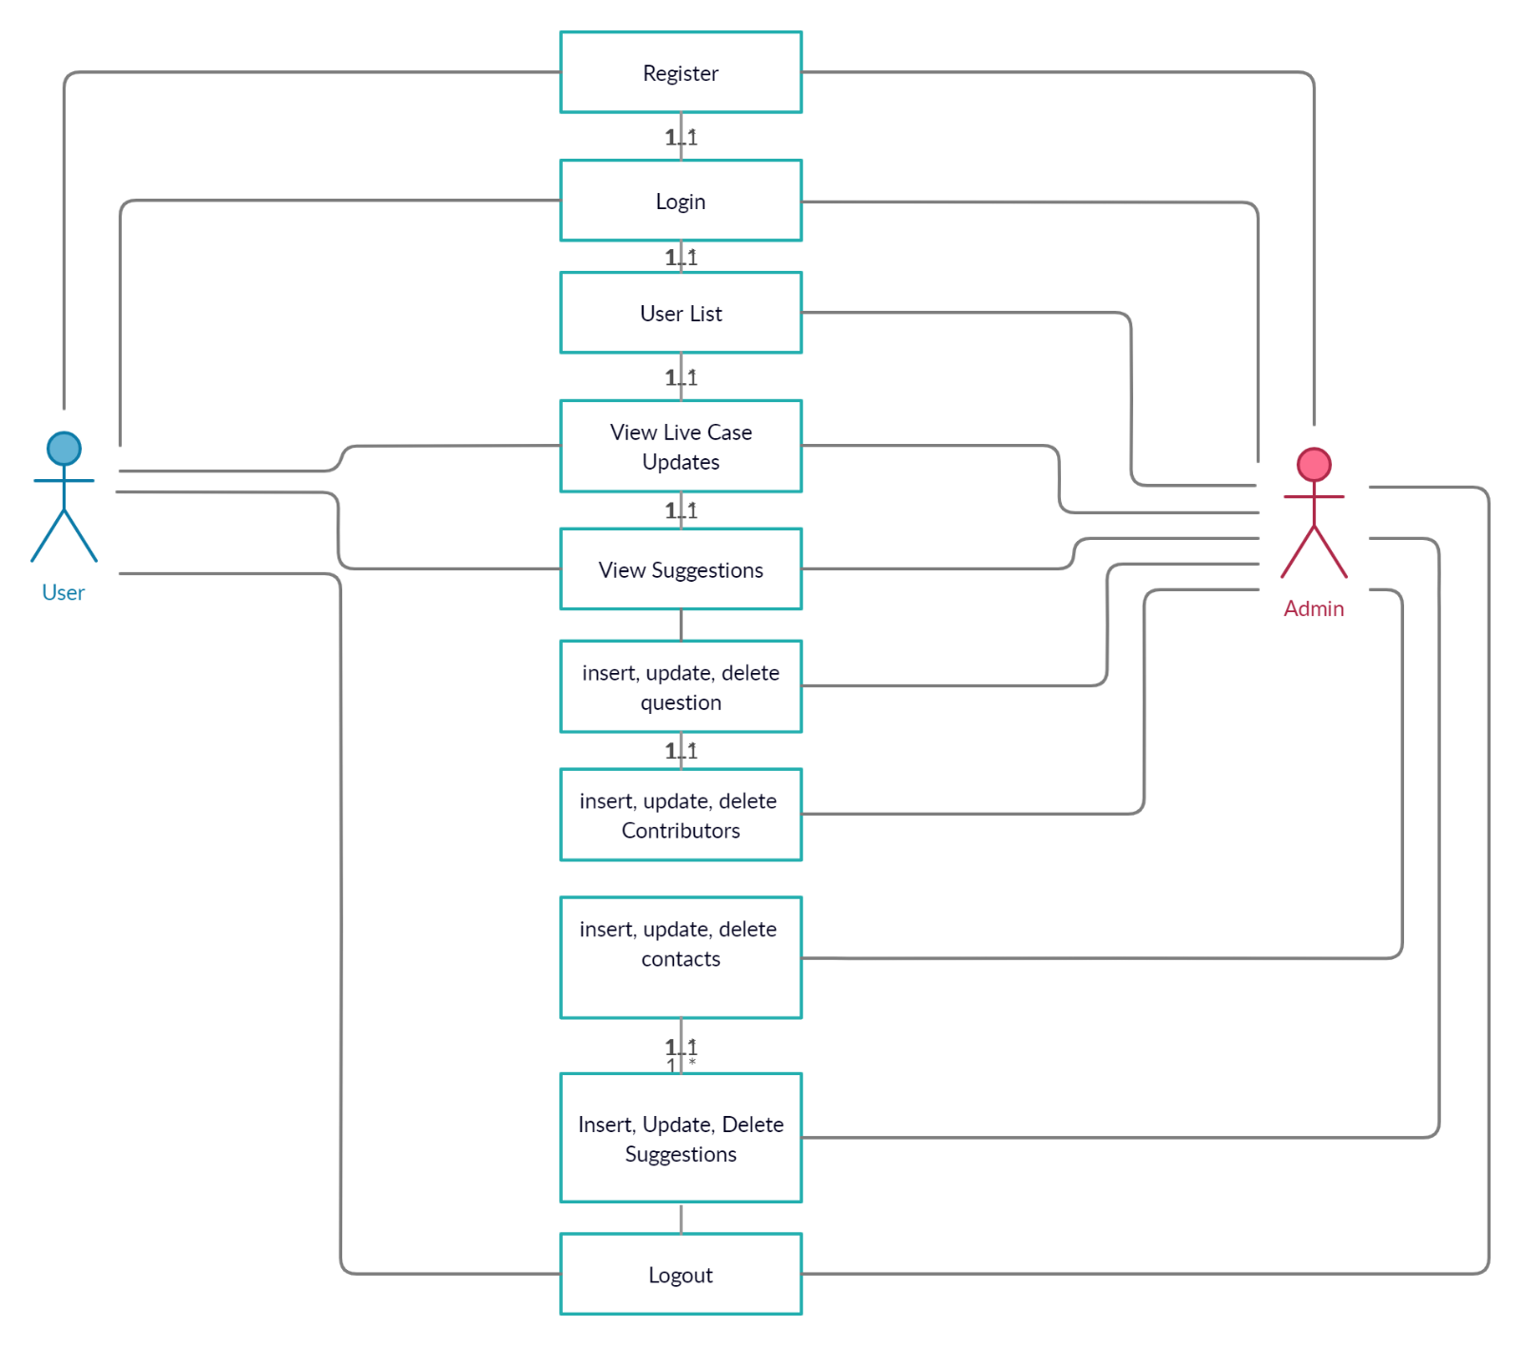

**E.R. Diagram**

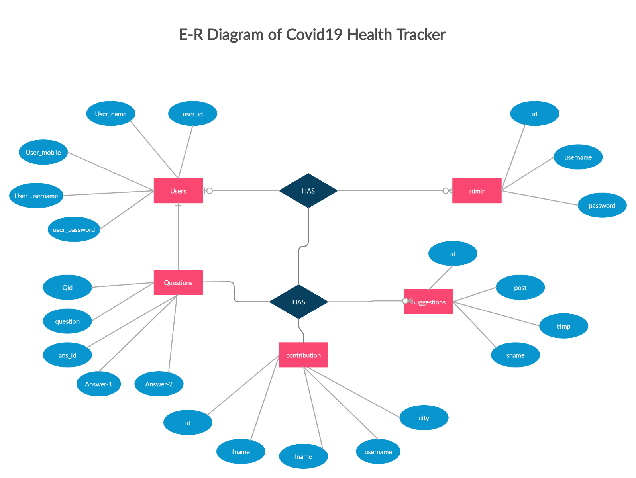

**Activity Diagram**

* **Admin Side:**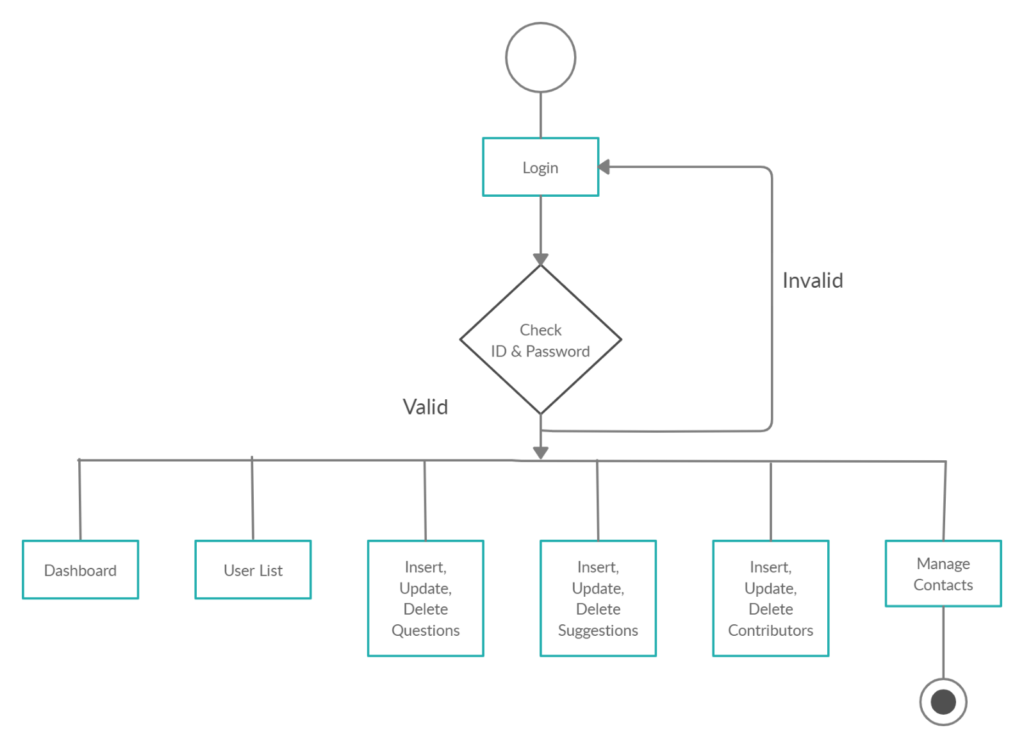

**Client Side :**

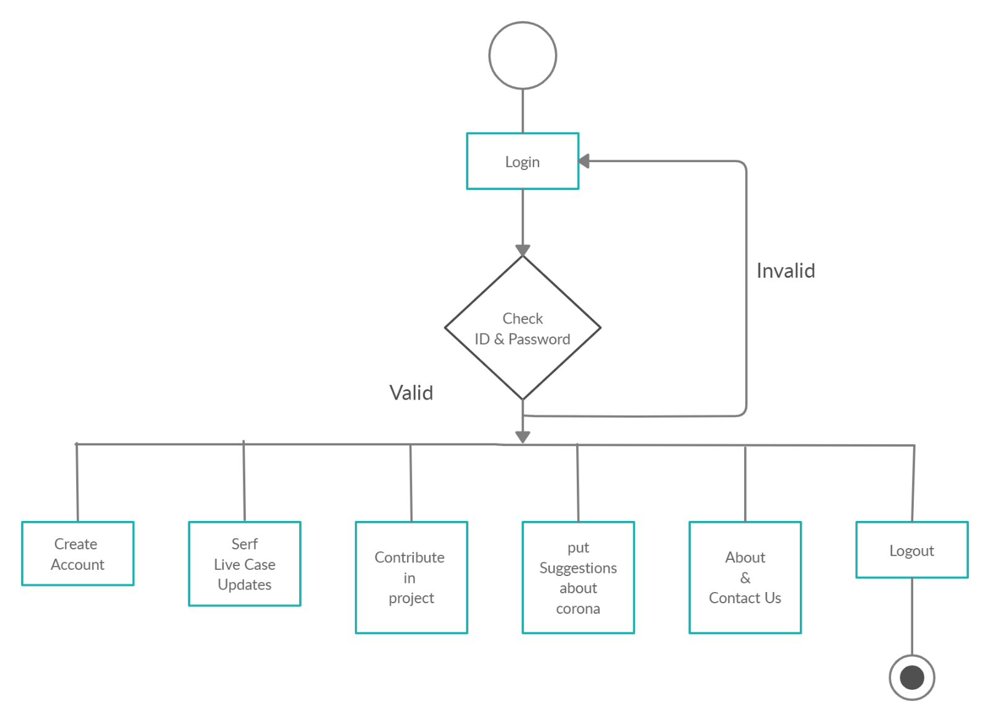

**Screenshots :**

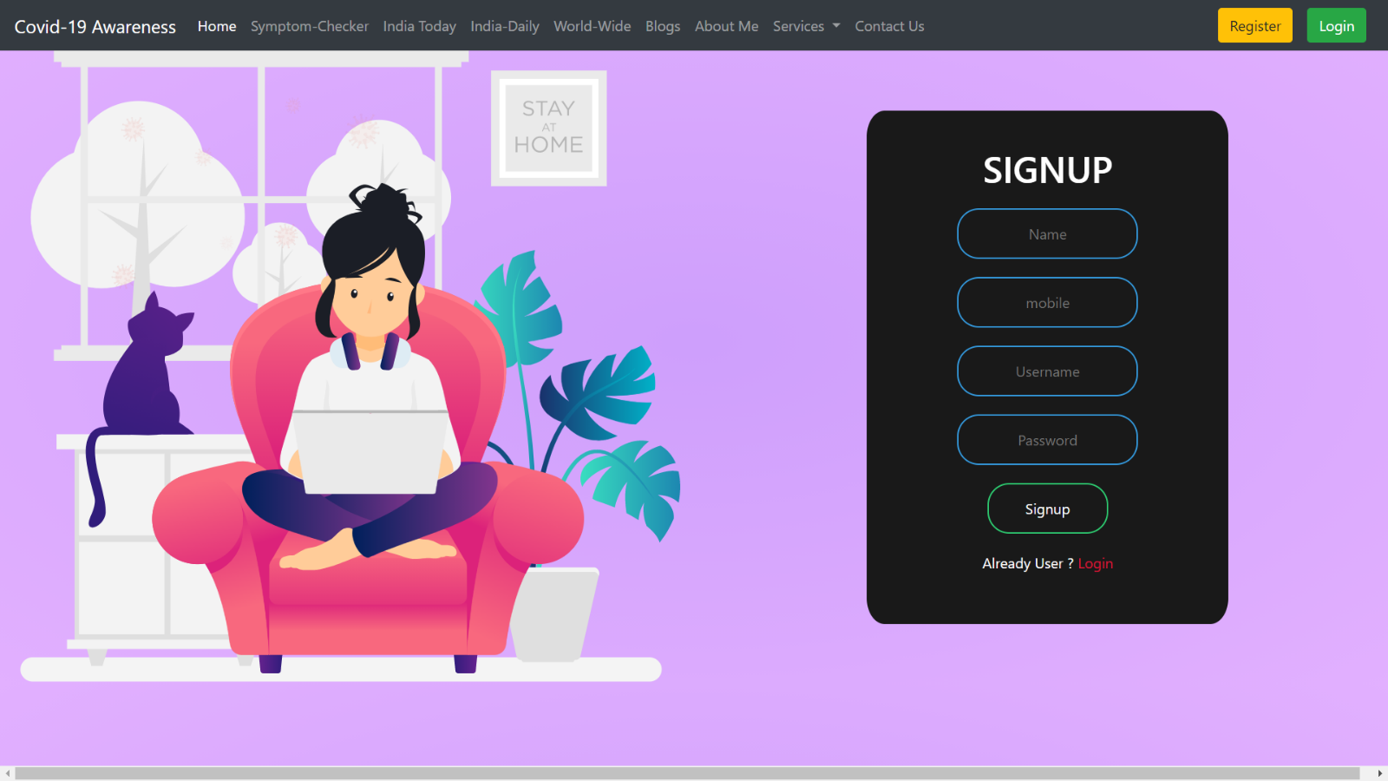

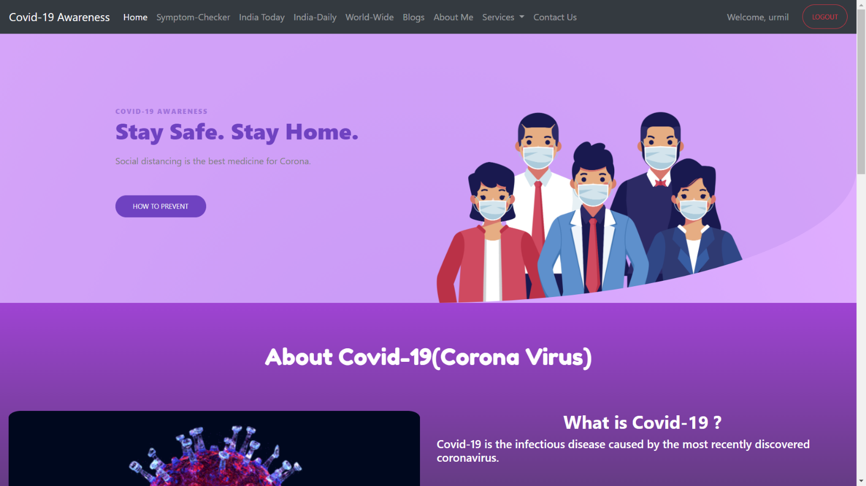

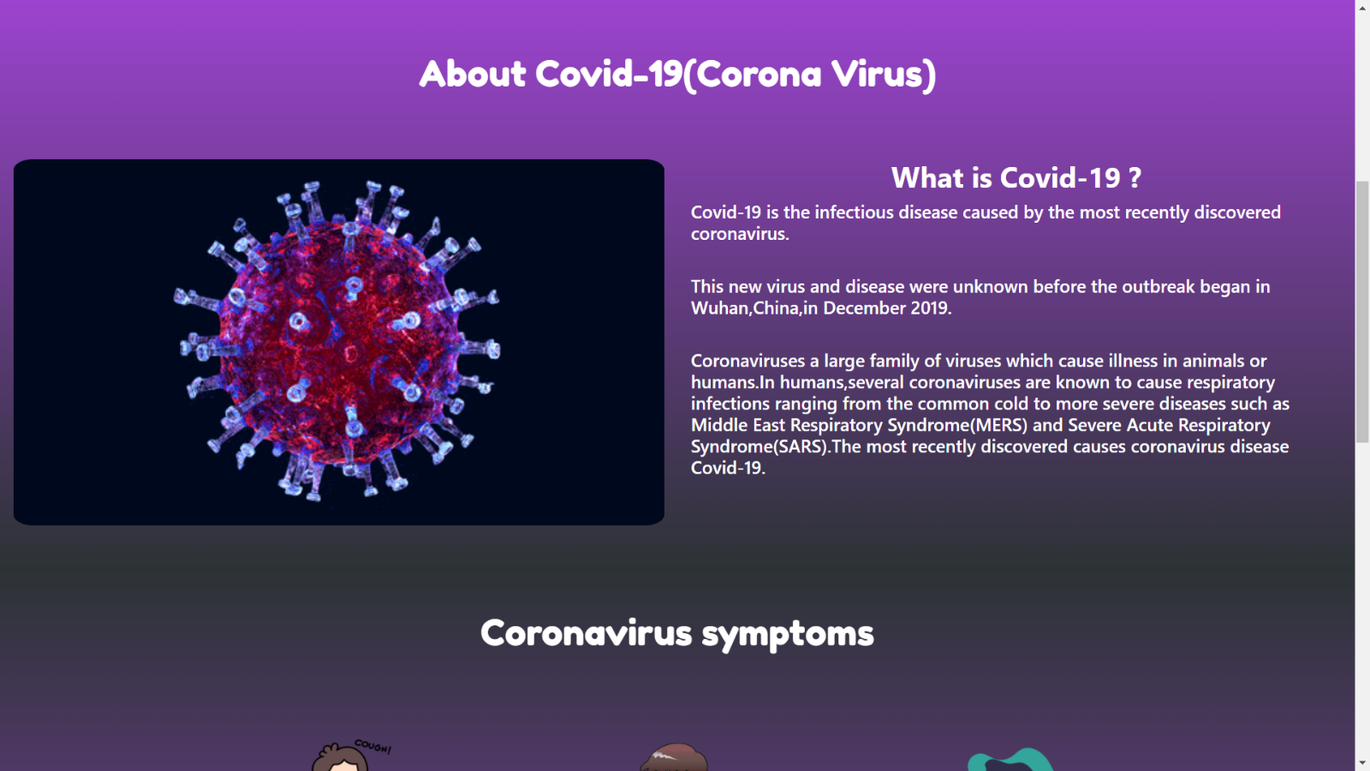

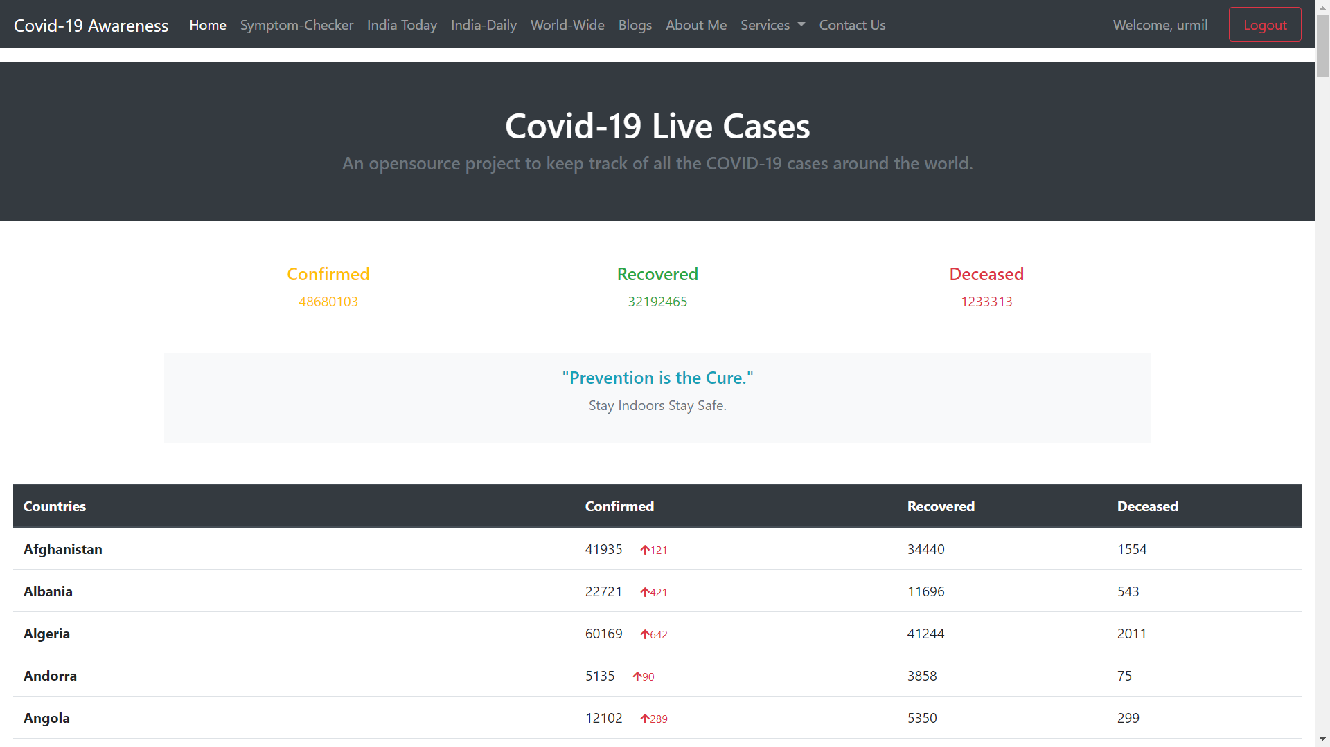

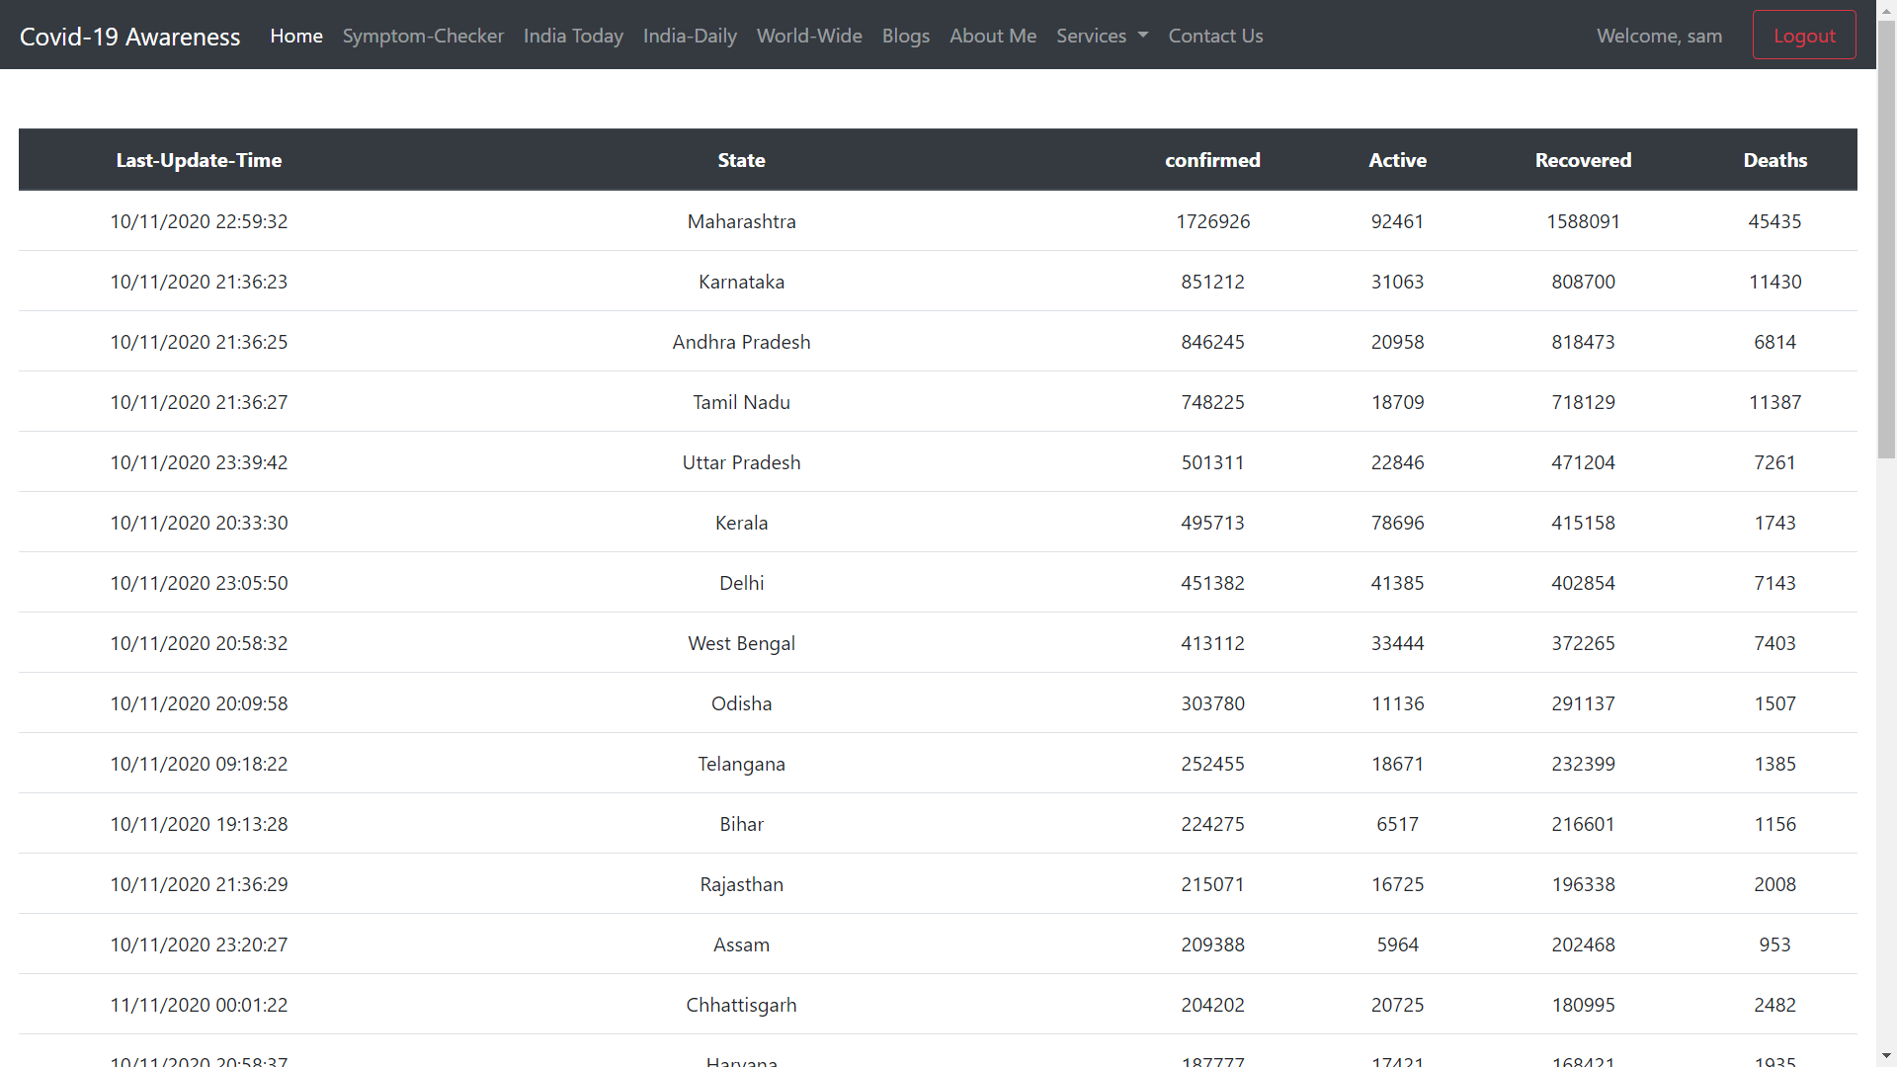

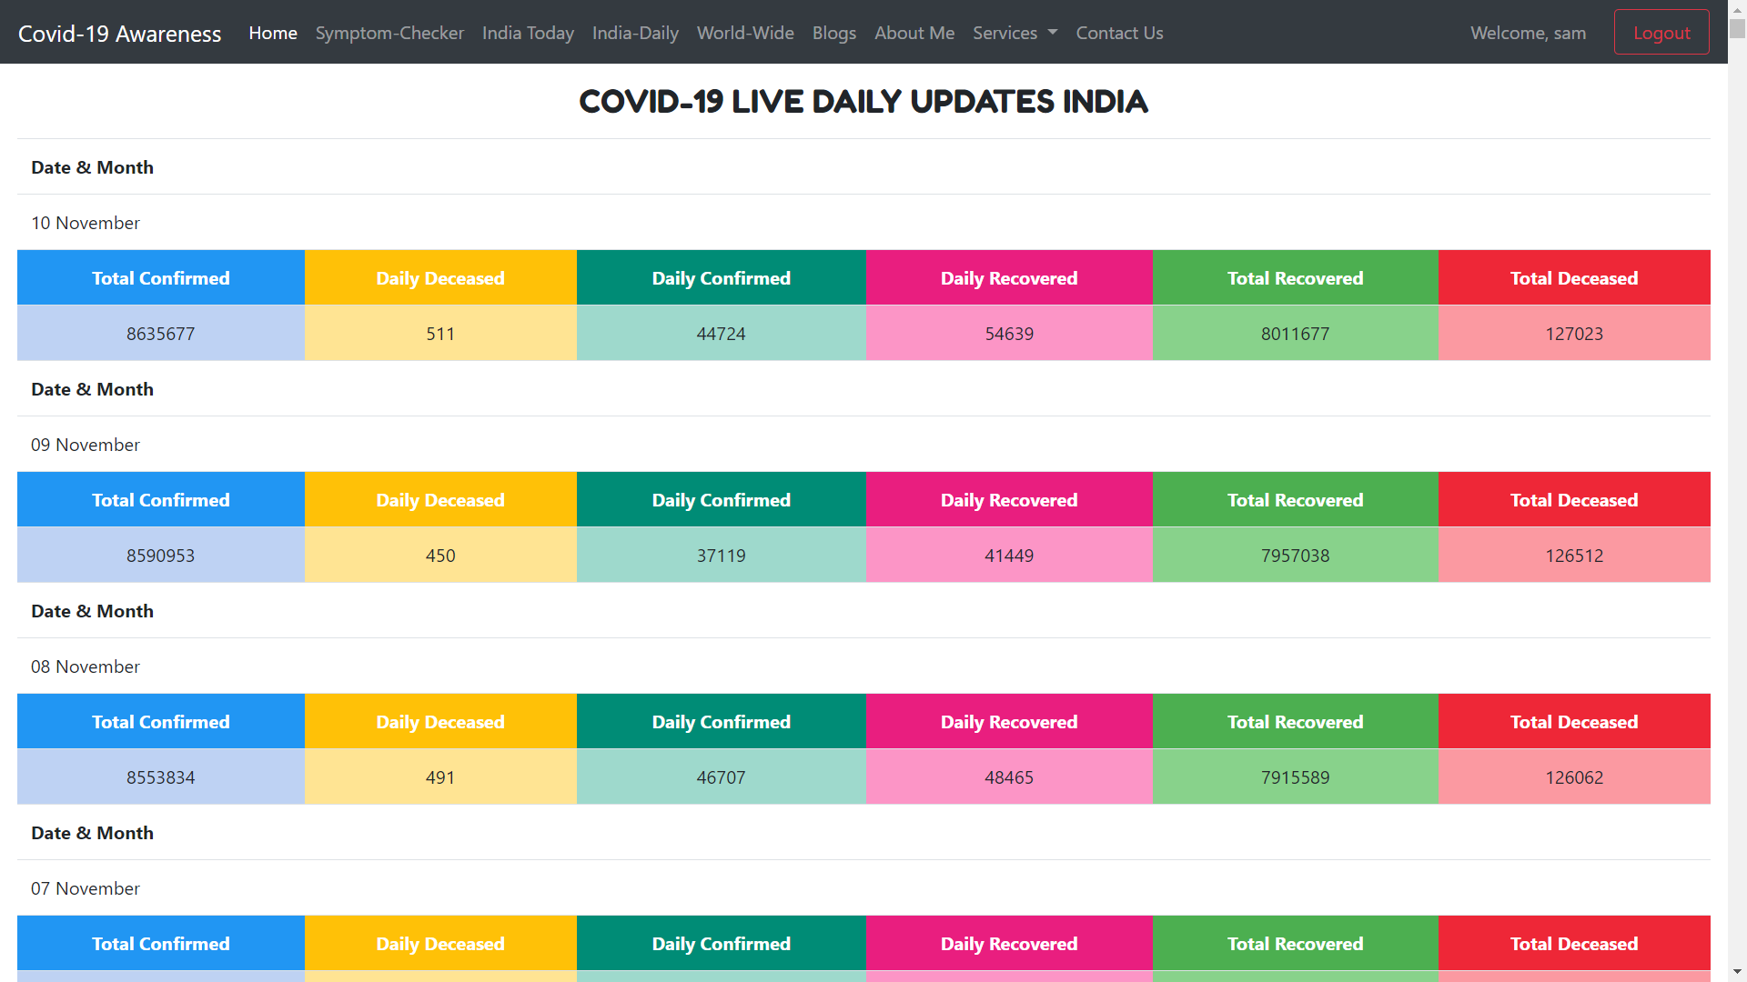

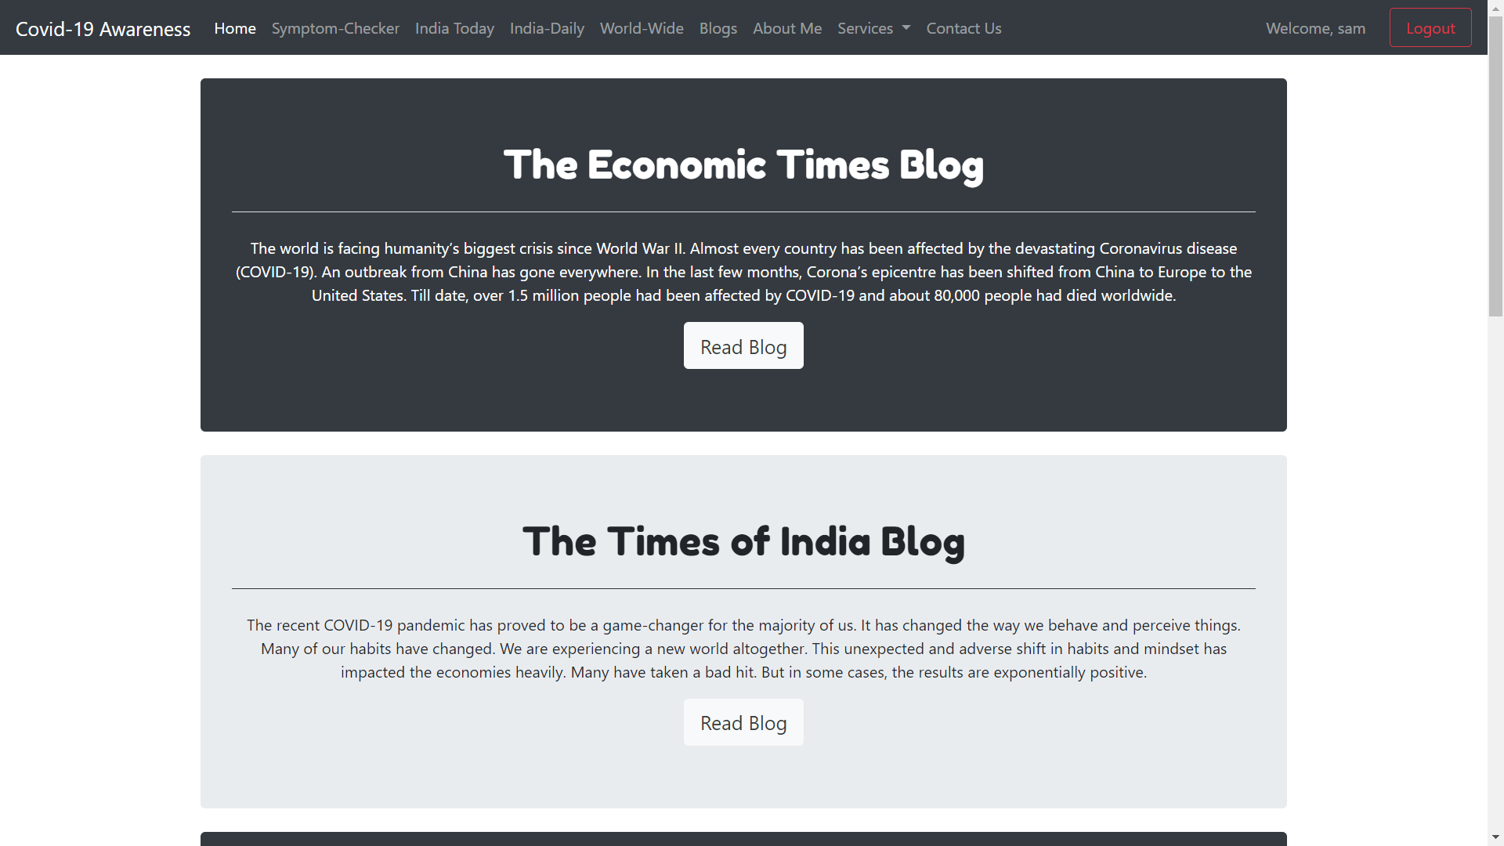

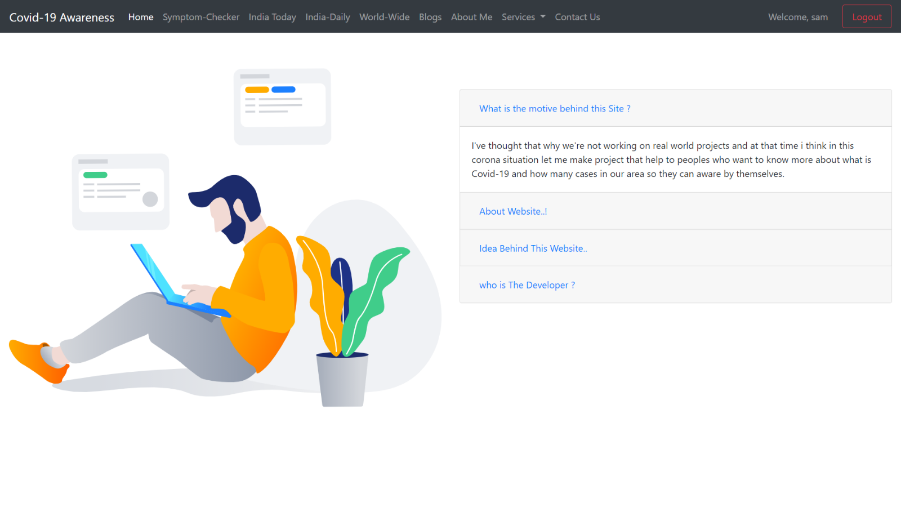

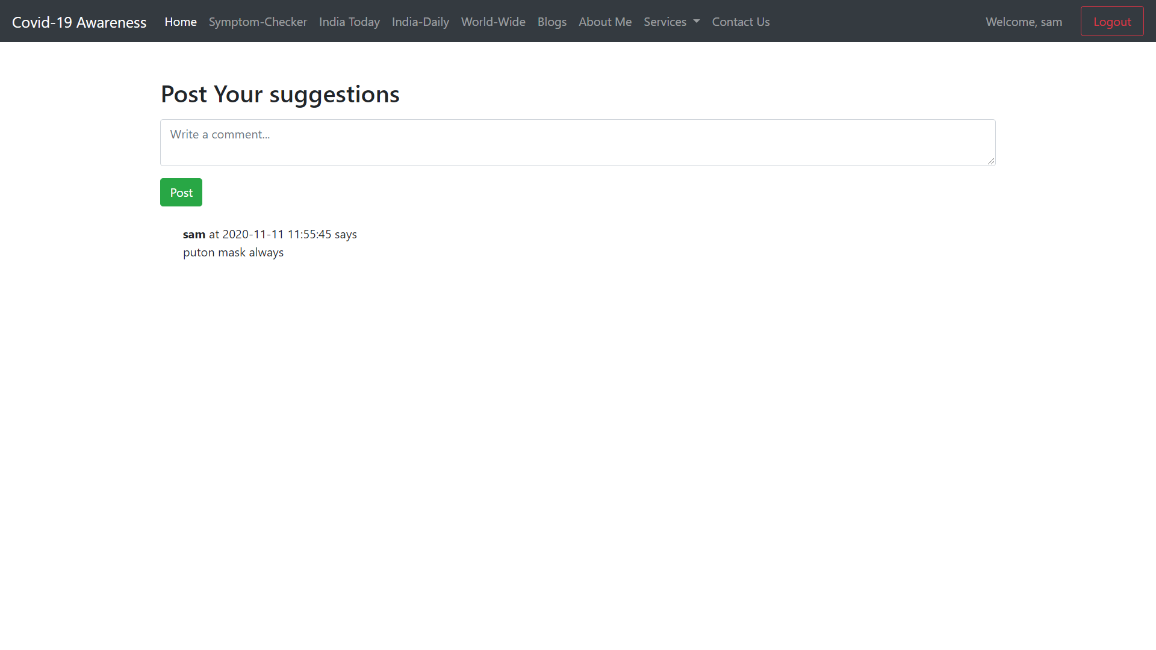

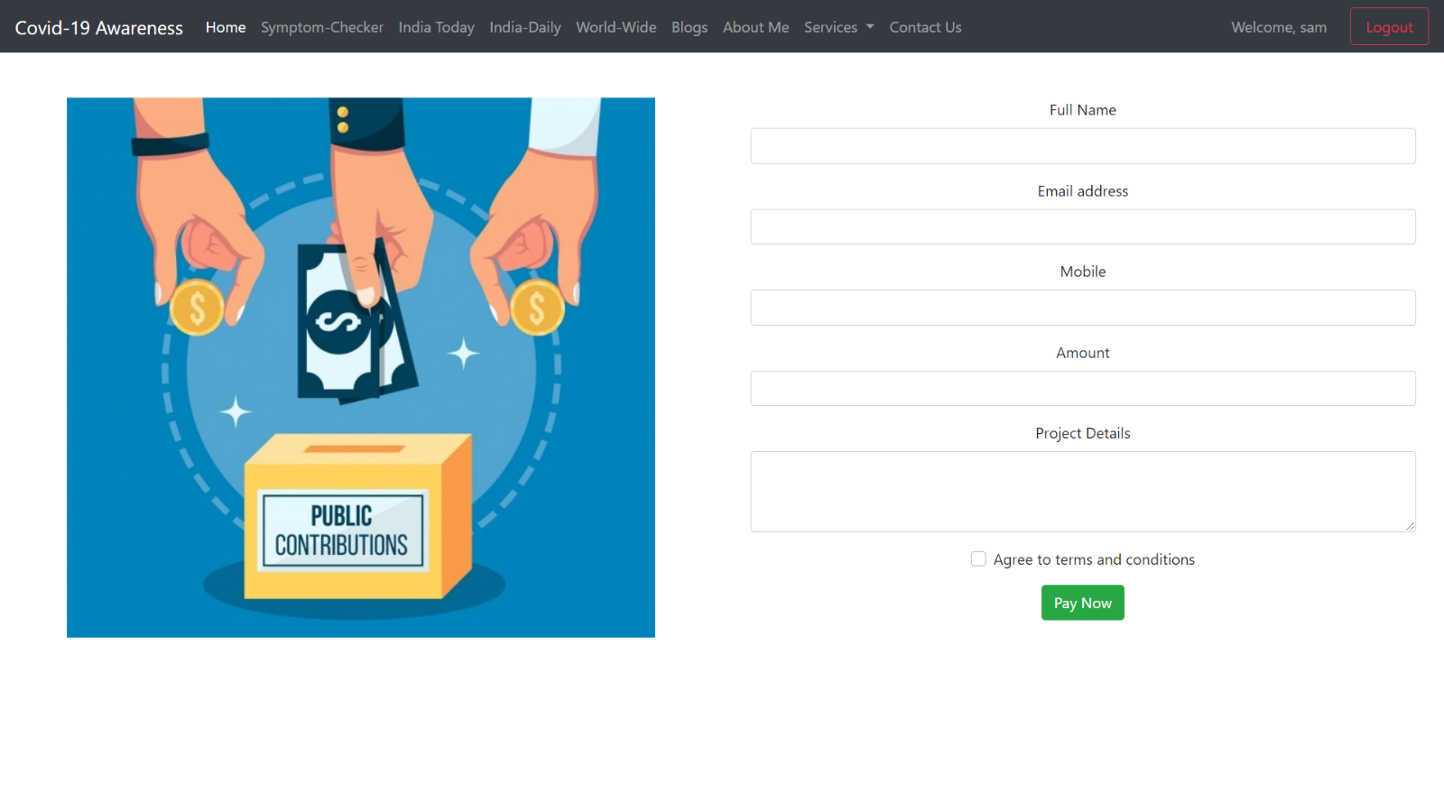

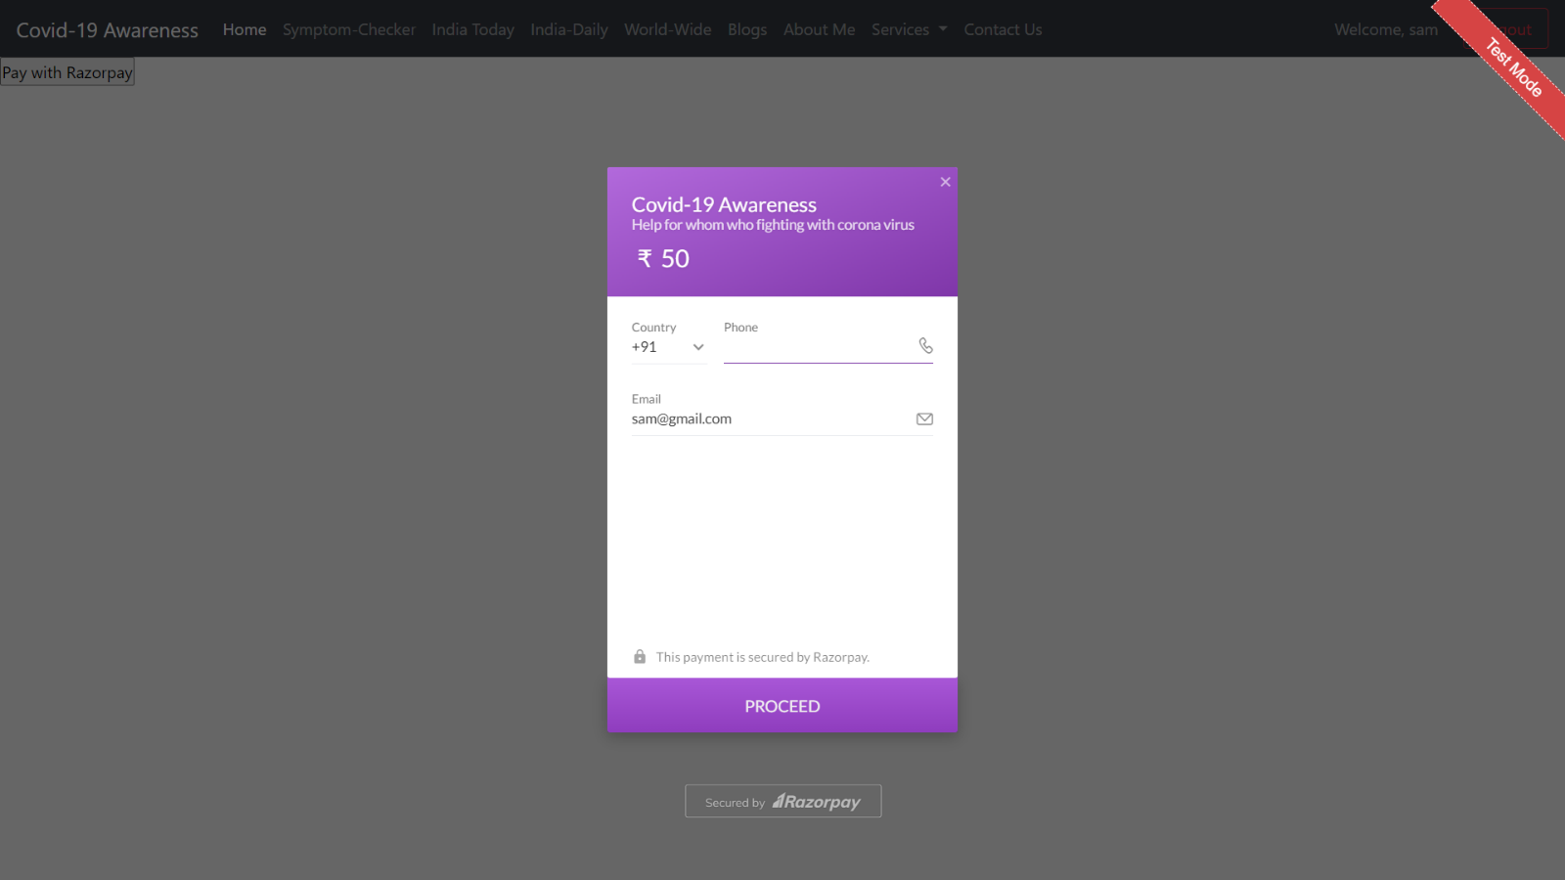

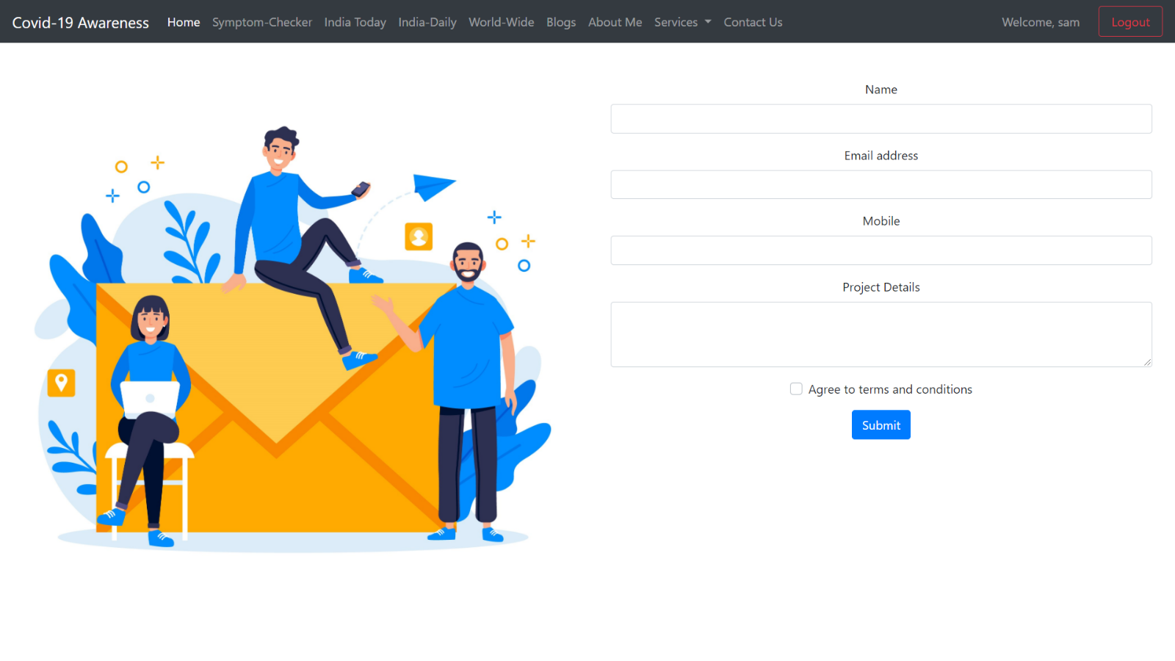

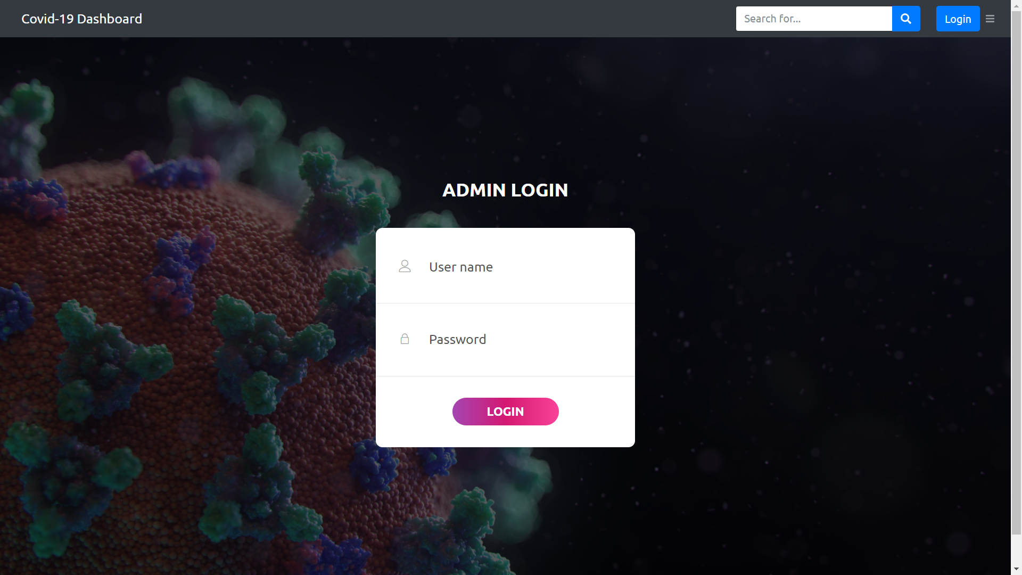

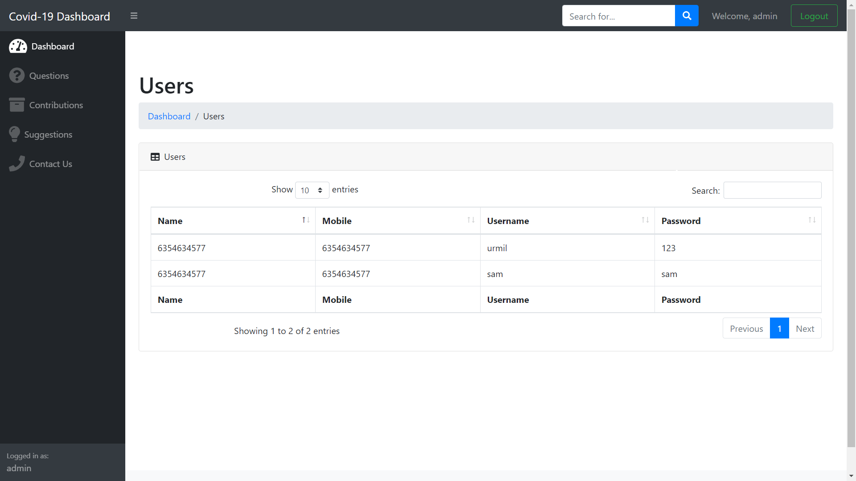

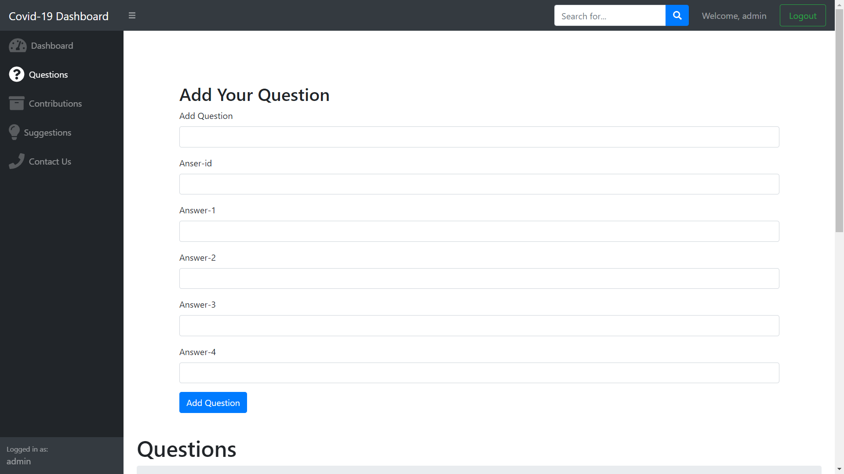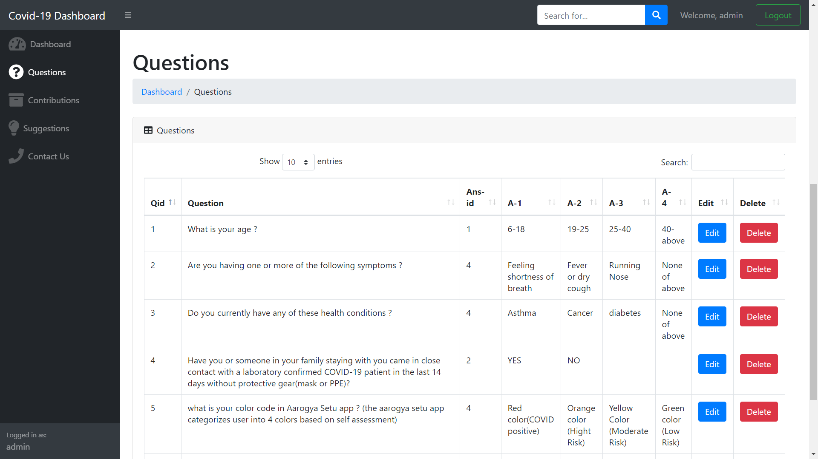

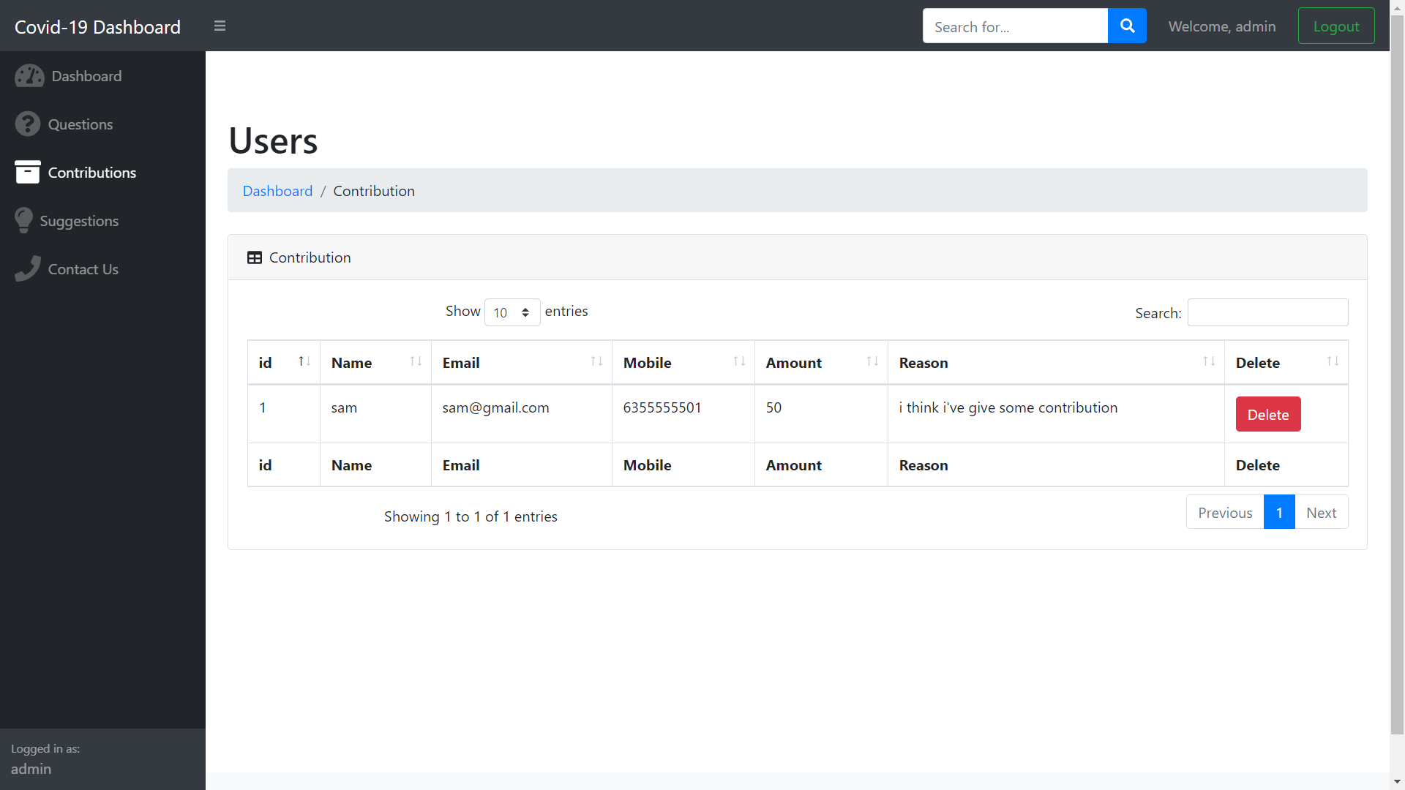

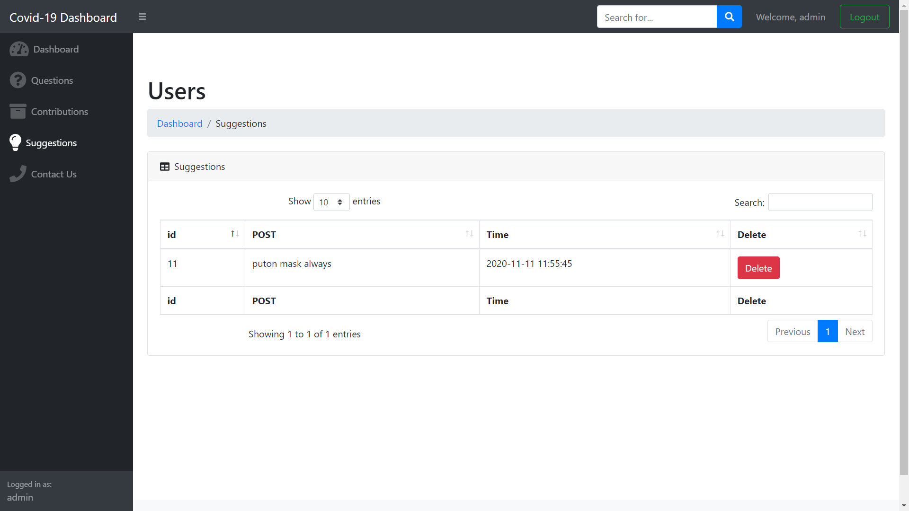

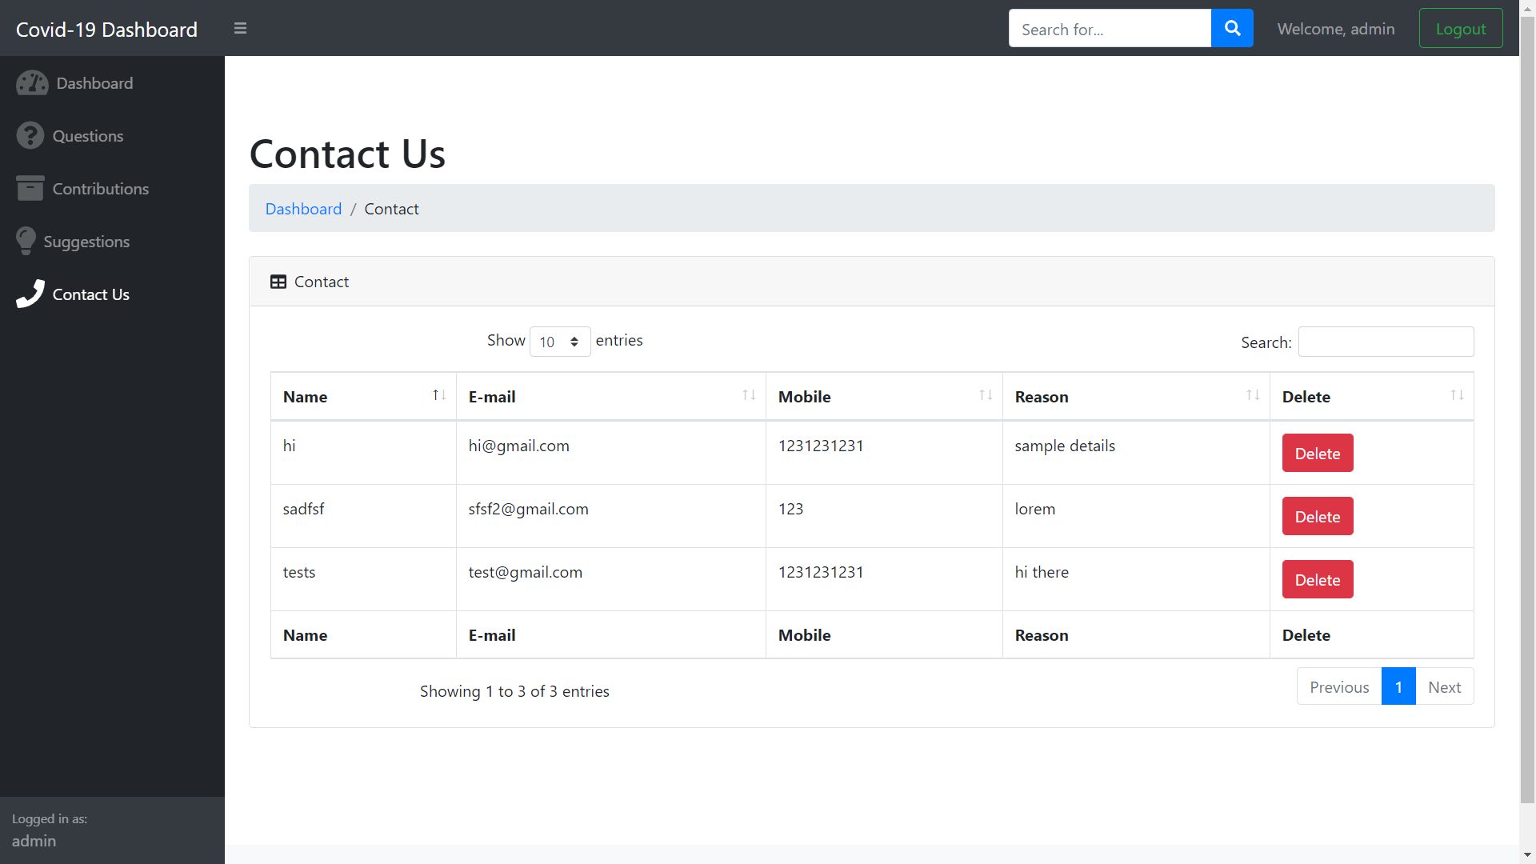

**Future Scope**

The future scope of this website can add more functionality like more security and privacy and adding net banking option for pay.

**Bibliography**

1. [**www.google.com**](http://www.google.com)
2. [www.stackoverflow.com](http://www.stackoverflow.com)
3. [www.api.covid19india.org](http://www.api.covid19india.org)
4. [www.github.com](http://www.github.com)